Academy
Mearns



Standard Grade

Physics

Unit 2: Health Physics

Revision Booklet

Please return this booklet to the

Physics Department

HEALTH PHYSICS REVISION BOOKLET (Credit Level in Bold Italic)

Section 1: The Use of Thermometers

Types of thermometers
Thermometers all have some physical property that changes with temperature e.g. an alcohol thermometer contains alcohol which expands as it gets hotter. Liquid crystal thermometers contain tiny crystals that change colour with temperature.

Clinical thermometers
A clinical thermometer is a thermometer used to measure core body temperature.
Clinical thermometers are different from normal laboratory thermometers in a number of ways. They have:
- a small range from 35 to 43°C so small temperature changes can be measured;
- a kink to prevent the mercury contracting back down the tube and changing the reading when the thermometer is removed from the patient;
- a triangular shape to magnify the fine mercury column and make reading the temperature easier.

Measuring body temperature
  - Shake the thread down to make the mercury go back into the bowl.
  - Place the bowl under the tongue and leave for a few minutes.
  - Read the scale opposite the end of the mercury thread to give the temperature.

Normal body temperature is 37°C.
If the temperature is above 37°C, the person is feverish, usually due to some infection; if the temperature is above 43°C the person is close to death!
If the temperature is below 34°C, the person is suffering from hypothermia; if the temperature is below 28°C the person is close to death!

Section 2: Using Sound

Sound is caused by vibrations and can only be transmitted when there are particles to vibrate; therefore sound travels through solids, liquids and gases but not through a vacuum.

The stethoscope picks up sounds from the body and passes the vibrations along a column of air in the tube to the doctor's ears; to receive a loud enough sound, the volume of air is kept small and the earpieces are a tight fit, also preventing background sounds being heard.

There are two bells in a stethoscope:
- an open bell for low frequency heart sounds,
- a closed bell for high frequency lung sounds.

The normal range of human hearing is approximately 20 Hz to 20 000 Hz; sounds with frequencies above this range are called ultrasounds.

Ultrasound is used to examine a baby in the womb (safer than X-rays) and break up kidney stones in the body (no surgery).

When used to examine the unborn baby, ultrasound is directed into the mother's body; a layer of jelly stops the skin reflecting the sound waves and enables the transfer of maximum energy; the waves reflect off the baby and these reflections are used to build up the image of the baby.

Noise levels are measured in decibels, dB; typical noise levels are:
minimum sound that can be heard 0 dB
ordinary conversation 60 dB
heavy lorry 95 dB
pneumatic drill 100 dB
pop group at 1 m 110 dB
jet engine 130 dB
pain threshold 140 dB

Regular exposure to noise above 90 dB can cause damage to hearing.
Noise levels from 90 dB upwards are examples of noise pollution. Learn at least two.

Section 3: Light and Sight

Refraction of light occurs when light moves from one material into another and is usually accompanied by a change in direction. It is caused by a change in speed in the different materials.
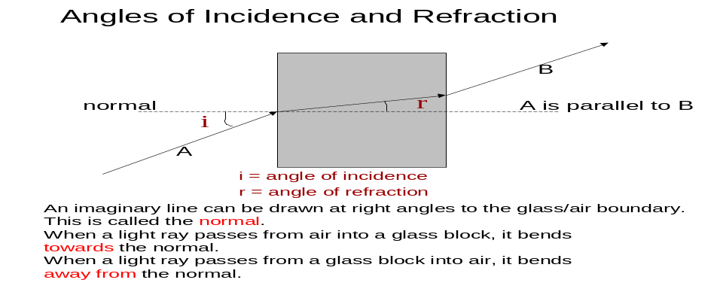

There are two main shapes of lens:

Convex (converging) Concave (diverging)

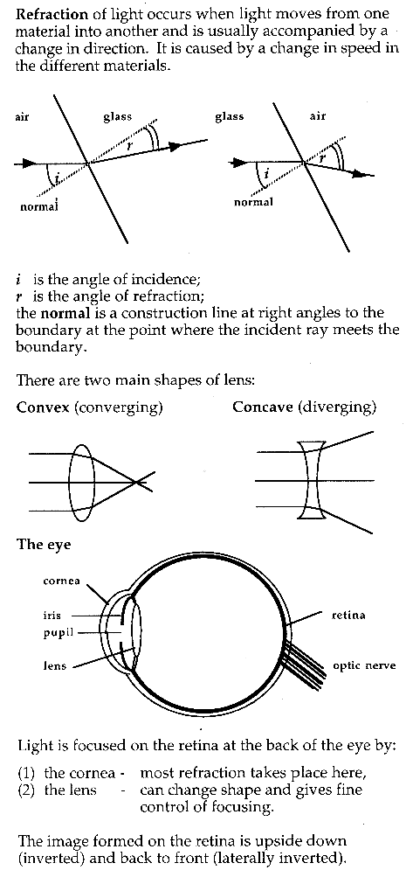

The Eye
Light is focused on the retina at the back of the eye by:
- the cornea - most refraction takes place here,
- the lens - can change shape and gives fine control of focusing.

The image formed on the retina is upside down (inverted) and back to front (laterally inverted).

A ray diagram shows that an inverted image is formed on the retina:
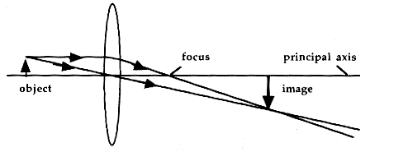
The position of any image can be found by drawing two rays:
- a ray through the centre of the lens which does not change direction,
- a ray parallel to the principal axis which goes through the focus.

The lens in the eye can change shape; this is called accommodation.
Light rays coming from a distant object arrive at the eye parallel; the lens is thin:

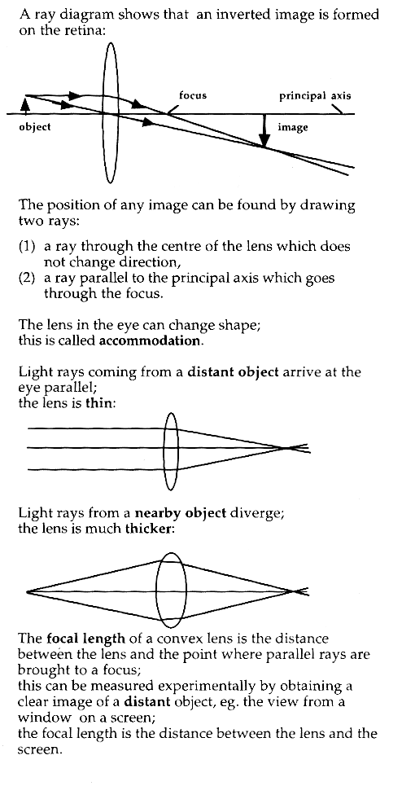

Light rays from a nearby object diverge; the lens is much thicker;

The focal length of a convex lens is the distance between the lens and the point where parallel rays are brought to a focus; this can be measured experimentally by obtaining a clear image of a distant object, e.g. the view from a window on a screen; the focal length is the distance between the lens and the screen.

People can only see clearly if the light is focused on the retina.
In long sight, light from nearby objects is focused behind the retina and only objects a long way away are clear.
In short sight, light from distant objects is focused in front of the retina and only objects nearby are clear.
Both long and short sight can be corrected using lenses.

Long sight
Use of a convex lens causes light to converge more, so that it is focused on the retina:

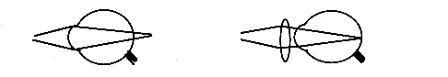
Short sight
Use of a concave lens causes light to diverge before it enters the eye so that it is focused on the retina:

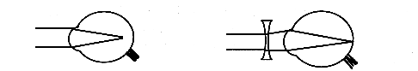

The power of a lens is measured in dioptres, D.
Power is related to focal length by the equation:

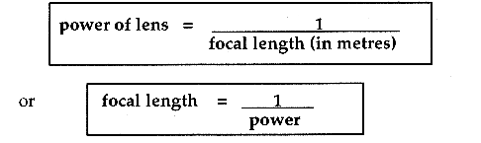

Both focal length and power are:
- negative for concave lens
- positive for convex lens

Fibre optics can be used to transmit' cold light’; since the source of the light can be a long way from the tip of the optical fibre, only the light reaches the tip and not the heat, i.e. 'cold light'.

An endoscope (or fibroscope) consists of two bundles of optical fibres; the first bundle carries cold light down to the tip; the second bundle has a lens at the tip and sends an image back up the fibre optic; the tube is flexible and can be moved around inside the body to view the inside. The light passes down the optical fibre by total internal reflection. For angles greater than the critical angle, light will only be reflected and not transmitted. The critical angle for glass is 42º.

Section 4: Using the Spectrum

A laser gives a very intense beam of light that carries a lot of energy. A laser can be used to remove birth marks, remove tumours, repair detached retinas and coagulate stomach ulcers.

X-rays can be used to find broken bones; the bone is dense enough to absorb X-rays while soft tissue lets X-rays through; this produces a 'shadow' picture of the bones, which appear white on a photographic film; where there is a break, there is a dark line.
Photographic film can be used to detect X-rays.

Computerised tomography (CAT scanning) takes a series of X-ray pictures of horizontal slices through the body; the X-ray tube rotates round the body to allow readings from all directions; the computer builds up a 3-D picture of the particular organ and can find very small changes; it allows tumours to be found while they are still small and the position accurately located so that they can be treated.

Infra red (heat) radiation can be used to help heal strained muscles and tissues.
Since tumours are slightly warmer than the surrounding tissue, thermograms that detect the infrared emitted by tissue can be used to find tumours.

Ultra violet can be used to treat skin problems such as acne; it is also used to sterilise instruments by killing bacteria.
Ultra violet is the part of the sun's radiation which causes tanning, but too much can cause skin cancer.

Section 5: Nuclear Radiation

Nuclear (ionising) radiation can kill or change the nature of living cells. Radiation can be used to sterilise instruments by killing germs or kill the cells that make up a cancerous tumour.

Radioactive material can be detected by the radiation it gives off.

Gamma radiation is used in medicine since it can be detected outside the body.
A tracer is a radioactive substance that is either injected into the body or swallowed; the tracer is concentrated in the organ the doctor wishes to examine and the movement of the tracer is measured by the gamma radiation, e.g. tracers can be used to study the uptake of iodine by the thyroid gland.

The energy carried by radiation can be absorbed by the material it is passing through.
There are three types of radiation:
alpha α
beta β
gamma γ

These three radiations can be identified by their different absorption properties.
The source is placed in front of a Geiger-Muller tube and the amount of radiation passing through the absorber registers on the counter; various absorbers can be used.

- Alpha radiation is absorbed by paper;
- beta radiation is absorbed by a few millimetres of aluminium;
- gamma radiation is absorbed by a few centimetres of lead.

- Alpha radiation is absorbed by a few centimetres of air;
- beta radiation is absorbed by a few metres of air;
- gamma radiation is not absorbed by air.

The atom consists of a central nucleus with orbiting electrons.
The nucleus contains positively charged protons and uncharged neutrons; it has nearly all of the mass of the atom and all the positive charge.
The electrons are negatively charged and much lighter (1/2000th) than neutrons or protons:
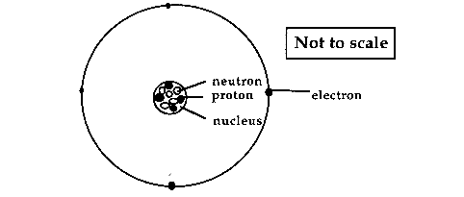

An atom is normally electrically neutral as it has the same number of negative electrons orbiting the atom as positive protons in the nucleus.

Ionisation occurs when the atom gains an electron to give it an overall negative charge, or loses an electron to give it an overall positive charge.
When radiation passes through a material it can ionise the atoms of that material.
Alpha particles produce much more ionisation than beta or gamma radiation.

Radiation will fog photographic plates.
This property is used in film badges; various parts of the film are covered by different thickness of various absorbers; when the badge is developed, the film will only be affected if radiation has passed through the absorber; by examining which areas are affected, the type and amount of radiation can be determined.

Radiation is absorbed by some materials and the energy re-emitted as light, called scintillations. This effect is used in scintillation counters and gamma cameras.

Ionisation takes place in the Geiger-Muller tube:

The activity of a radioactive source is measured in becquerels, Bq, where one becquerel is one atom decaying per second.
The activity of a radioactive source decreases with time.

Safety precautions for handling radioactive material include:
- always use forceps to handle sources,
- make sure the source is never pointed at anyone,
- store in lead-lined boxes,
- label all radioactive material.

The biological effect of radiation depends on:
- the type of radiation,
- the type of body tissue which absorbs it,
- the total amount of energy absorbed.

The dose equivalent is measured in sieverts, Sv. The dose equivalent takes into account the type and energy of the radiation.

The decay of an individual atom is a totally random event and cannot be predicted.
However the time taken for half the atoms, in a sample of a particular radioactive material, to decay is always the same; this is called the half-life.
The half-life is the time taken for the activity of a sample to drop by half.
The half-life can be found from an Activity/Time graph.

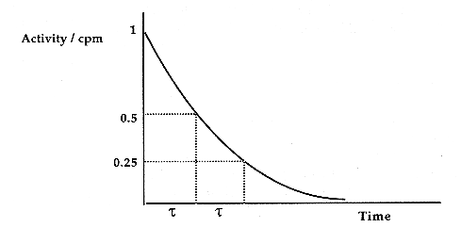

The initial activity is marked on the graph and then a line parallel to the time axis is drawn at half this activity; from the point where the line meets the curve, a line parallel to the activity axis is drawn; the half life is given by the point where the line cuts the time axis.
Any initial activity can be chosen; the half-life will always be the same for a given radioactive material.

In any half-life calculations, remember to subtract background radiation.

